Test # 184
Instrument Name Consistometer
Instrument Type Consistometer
Test Start 13/02/01 13:04
Test Stop 7:17:33
Well ID # Unidentified
Customer KOGALYM-LUKOIL AIK
Cement Class G
Additives 1.25%TDF-1+Defoamer
Cement Mfr DYKERHOFF
BHCT 40
BHST 40
Density 1900
Fluid Loss 58 cc/30min
Job Type 146 MM CSG HESITATION SQUEEZE
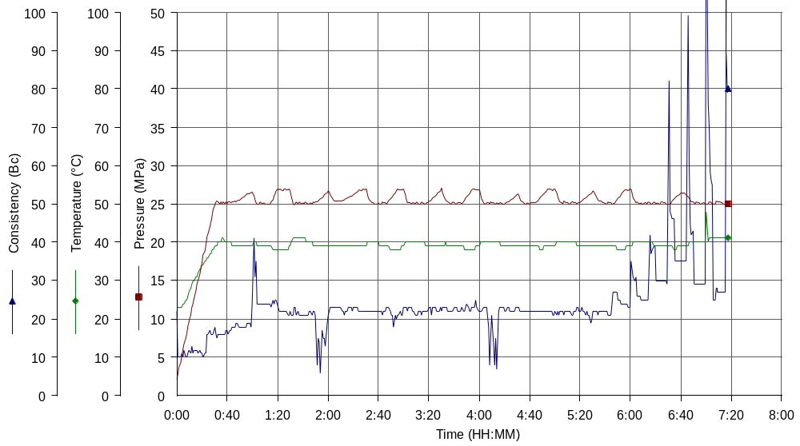
Comments MPa: 25(30.2min), T: 40(30.2min), Squeeze Cycle Start Time = 50min; Standard API Cycle

